ancRequired Libraries and Installation Steps for zupbatch.py

- System Update (Debian/Ubuntu)
sudo apt update sudo apt upgrade
- Python Package Manager Update
python -m pip install --upgrade pip
- Required Python Libraries
The following Python libraries are required by your script:
time (standard library)
os (standard library)
board
busio
digitalio
adafruit-rfm9x
zipfile (standard library) pydrive

Install/Update Required Python Packages
pip3 install adafruit-blinka
(pip install --upgrade adafruit-circuitpython-board
pip install --upgrade adafruit-circuitpython-busio
pip install --upgrade adafruit-circuitpython-digitalio)
pip3 install --upgrade adafruit-circuitpython-rfm9x
pip3 install --upgrade PyDrive
pip3 install --upgrade adafruit-circuitpython-ssd1306

Note:
time, os, and zipfile are part of the Python standard library and do not require installation.
The adafruit-circuitpython-* packages provide board, busio, digitalio, and adafruit_rfm9x.
PyDrive provides pydrive.auth and pydrive.drive.
You can copy and run these commands in your terminal to ensure all dependencies are up to date and installed.

step-by-step and command-by-command — for setting up a SIM7600/7670 GSM module on a new Raspberry Pi (any model), for internet access via PPP.

✅ GSM Internet Setup on Fresh Raspberry Pi

⚙️ Requirements:
- Raspberry Pi (with UART enabled)
- SIM7600/7670 GSM module (connected to /dev/serial0)
- Inserted SIM with data plan
- APN info for your mobile provider

🔁 Step-by-Step Setup Commands

🔧 1. Enable Serial (UART) on Pi
Run:
sudo raspi-config
Then:
- Go to Interface Options → Serial Port
- Disable login shell over serial
- Enable serial hardware
Then reboot:
sudo reboot

📦 2. Install PPP and Minicom
sudo apt update
sudo apt install ppp minicom -y

📁 3. Create GPRS Chat Script
sudo tee /etc/chatscripts/gprs > /dev/null <<EOF
ABORT "BUSY"
ABORT "NO CARRIER"
ABORT "ERROR"
REPORT CONNECT
TIMEOUT 10
"" "ATZ"
OK 'AT+CGDCONT=1,"IP","internet"'
OK "ATD*99#"
CONNECT ""
EOF

Note:
Replace "internet" with your SIM card's APN (e.g., airtelgprs.com, jionet, etc.)

🧩 4. Create PPP Peer File
sudo tee /etc/ppp/peers/gprs > /dev/null <<EOF
/dev/serial0
115200
connect "/usr/sbin/chat -v -f /etc/chatscripts/gprs"
noipdefault
defaultroute
replacedefaultroute
usepeerdns
persist
noauth
ms-dns 8.8.8.8
ms-dns 1.1.1.1
EOF

🌐 5. Set Permanent DNS
echo -e "nameserver 8.8.8.8\nnameserver 1.1.1.1" | sudo tee /etc/resolv.conf
sudo chattr +i /etc/resolv.conf

🔌 6. Connect to GSM Internet
sudo pon gprs

Check connection:
ip addr
ip route
curl ifconfig.me
ping -c 4 8.8.8.8

❌ 7. Disconnect
sudo poff gprs

🔁 Auto-Connect GSM on Boot (Optional)

Add to rc.local:
sudo nano /etc/rc.local

Add before exit 0:
sleep 10
sudo pon gprs

Or create a systemd service (ask me if needed).

🛠️ AT Command Testing (Optional)
Install and use minicom:
sudo minicom -D /dev/serial0 -b 115200

Try these:
AT
AT+CSQ # Signal
AT+CREG? # Network registration
AT+COPS? # Operator
AT+CGATT? # GPRS attached?
AT+CGDCONT=1,"IP","your.apn"

🧽 Extra Commands for Debugging
sudo pon gprs # Start connection
sudo poff gprs # Stop connection
ip route # Check default route
ping 8.8.8.8 # Test Internet
cat /etc/resolv.conf # Confirm DNS
ps -ef | grep ppp # See if pppd is running
sudo kill -9 <pid> # Kill locked serial process

Would you like a shell script that automates this entire setup (for cloning on new devices)?
IMP for fast internet
Option 2: Globally Prefer IPv4
Edit or create the file /etc/gai.conf and uncomment or add this line:
bash
CopyEdit
precedence ::ffff:0:0/96 100
You can do this with:

bash
CopyEdit
sudo nano /etc/gai.conf
Then save and reboot your Pi.
This tells the system to prefer IPv4 for hostnames (like google.com), which should fix all such connectivity problems.

Circuit Documentation

Summary
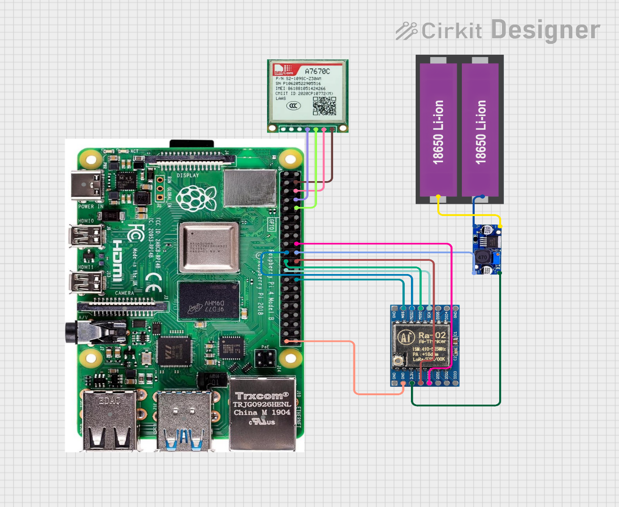
This circuit is designed to integrate a Raspberry Pi 4 with a LoRa module (RA-02 SX1278) and a GSM module (Sim A7670c), powered by a dual 18650 Li-ion battery setup through a buck converter. The Raspberry Pi serves as the central processing unit, interfacing with the LoRa and GSM modules for communication purposes. The buck converter steps down the voltage from the battery to power the components.
Fig 1 Connection diagram of server

Component List
- Raspberry Pi 4
  - A versatile single-board computer used for processing and interfacing with other components.
  - Key Pins: 5V power, 3v3 power, multiple GPIOs for communication and control.
- BUCK CONVERTER
  - Converts the voltage from the battery to a suitable level for the Raspberry Pi and other components.
  - Key Pins: IN +, IN -, OUT +, OUT -.
- 18650 Li-ion Battery x 2
  - Provides the primary power source for the circuit.
  - Key Pins: +, -.
- RA-02 SX1278
  - A LoRa module used for long-range wireless communication.
  - Key Pins: 3.3 V, GND, SCK, MOSI, MISO, NSS (CS), RST, DIO 0.
- Sim A7670c
  - A GSM module used for cellular communication.
  - Key Pins: Vin, Gnd, Tx, Rx.

Wiring Details

Raspberry Pi 4
- 5V power: Connected to Sim A7670c Vin.
- GND: Connected to RA-02 SX1278 GND, Sim A7670c Gnd, and BUCK CONVERTER OUT -.
- GPIO 11 (SCLK): Connected to RA-02 SX1278 SCK.
- GPIO 10 (MOSI): Connected to RA-02 SX1278 MOSI.
- GPIO 9 (MISO): Connected to RA-02 SX1278 MISO.
- GPIO 7 (CE1): Connected to RA-02 SX1278 NSS (CS).
- GPIO 25: Connected to RA-02 SX1278 RST.
- GPIO 24: Connected to RA-02 SX1278 DIO 0.
- GPIO 14 (TXD): Connected to Sim A7670c Rx.
- GPIO 15 (RXD): Connected to Sim A7670c Tx.

BUCK CONVERTER
- IN +: Connected to 18650 Li-ion Battery +.
- IN -: Connected to 18650 Li-ion Battery -.
- OUT +: Connected to RA-02 SX1278 3.3 V.
- OUT -: Connected to Raspberry Pi 4 GND.

18650 Li-ion Battery x 2
- +: Connected to BUCK CONVERTER IN +.
- -: Connected to BUCK CONVERTER IN -.

RA-02 SX1278
- 3.3 V: Connected to BUCK CONVERTER OUT +.
- GND: Connected to Raspberry Pi 4 GND.
- SCK: Connected to Raspberry Pi 4 GPIO 11 (SCLK).
- MOSI: Connected to Raspberry Pi 4 GPIO 10 (MOSI).
- MISO: Connected to Raspberry Pi 4 GPIO 9 (MISO).
- NSS (CS): Connected to Raspberry Pi 4 GPIO 7 (CE1).
- RST: Connected to Raspberry Pi 4 GPIO 25.
- DIO 0: Connected to Raspberry Pi 4 GPIO 24.

Sim A7670c
- Vin: Connected to Raspberry Pi 4 5V power.
- Gnd: Connected to Raspberry Pi 4 GND.
- Rx: Connected to Raspberry Pi 4 GPIO 14 (TXD).
- Tx: Connected to Raspberry Pi 4 GPIO 15 (RXD).

